# 1. Start SSMS.

Click **All Programs\ Microsoft SQL Server 2012\ SQL Server Management Studio**

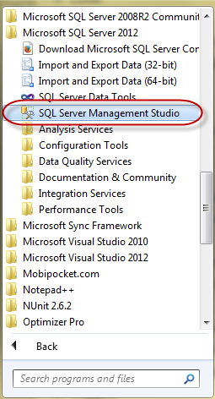

# 2. Connect to Server

* Choose **Server type** as *Database Engine*
* Choose **Authentication** as *Windows Authentication* or *SQL Server Authenticatione*
* Then click **Connect**

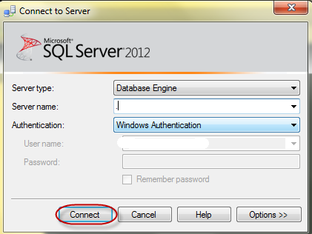

# 3. Query Editor

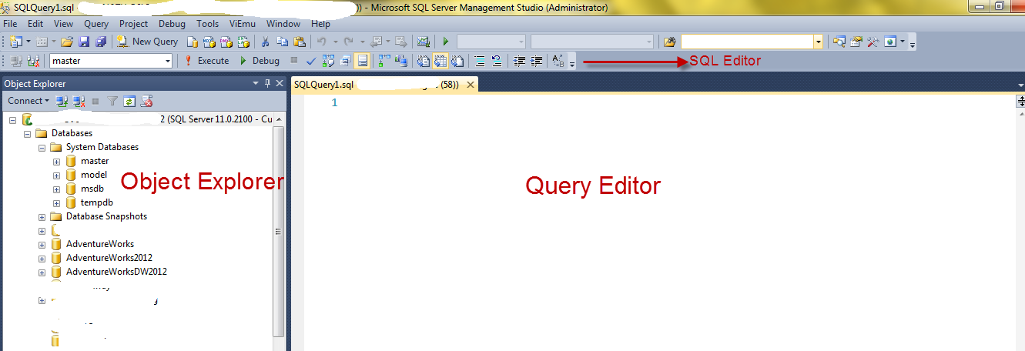

## Object Explorer: Manage database objects.

- **master** database: Stores system-level information

- **model** database: Is used as the template for all database. When a database is created, SQL Server copy the contents of the model database to the new database

- **msdb** database: Is used by SQL Server Agent for scheduling jobs.

- **temp** database: Is used to hold temporary objects...For instance, in SSMS enters:

create table #temp (Id int)

run this under *AdventureWorks* database. Then, go to *tempdb* database, this table is hold in **Temporary Tables**

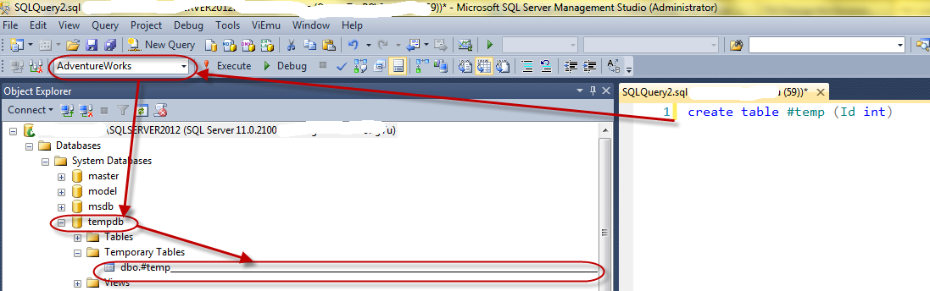

# 4. Debug in SSMS

SQL Server from 2005 version and above support Debug feature like Visual Studio. In SSMS, click **Debug** button.

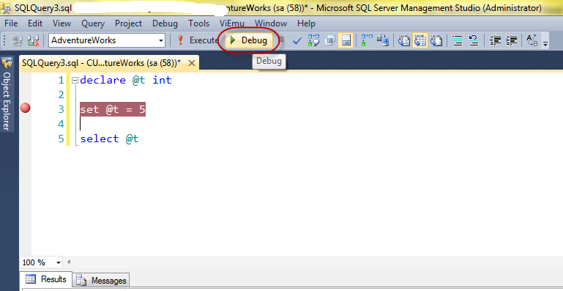

Then, we can see **QuickWatch** window just like Visual Studio.

